Fixing Pedestrian-, Bike-, and Transit-Unfriendly Aspects of Signal Control at the Casey Arborway Intersections

Peter G. Furth, Professor
Milad Tahmasebi, Graduate Research Assistant
Northeastern University
April 2, 2021

Summary
Casey Arborway, at Forest Hills in Boston, is a newly constructed roadway with a lot of good features for bikes, transit, and pedestrians, such as cycle tracks, bike signals, relatively small footprint intersections (for the volume of traffic carried), and a left turn lane just for buses. Nevertheless, the way the traffic signals operate at its two main intersections has some decidedly pedestrian-, bike-, and transit- unfriendly features that we hope, by bringing them to light, will quickly be corrected.
At the South Street / Casey Arborway intersection, many of the pedestrian and bike crossings are multi-stage crossings because of a slip lane serving eastbound right turns on Arborway. Poor coordination between the different crossing stages results in average pedestrian delay of 241 seconds (more than 4 minutes) for pedestrians crossing Arborway southbound, including long waits on the median and at the delta island associated with the slip lane. By better coordinating crossing phases, average delay for that southbound crossing could be reduced to 52 seconds. For bikes, average delay for the same crossing, currently 121 seconds, could be reduced to 40 seconds. Considering the four affected crossings, average delay could be reduced from 115 to 38 seconds for pedestrians, and from 90 to 38 seconds for bikes. With that large delay reduction will come an improvement in compliance and reduction in queuing on the islands.
Also at the South Street intersection, a leading pedestrian interval (LPI) that is intended to protect pedestrians from right turning traffic is, inadvertently, exposing them to danger from left-turning traffic. Eliminating this LPI would substantially improve pedestrian safety.
At the Washington / Casey Arborway intersection, three issues were detected. First, abuse of a bus-only left turn phase is leaving some buses waiting up to 6 minutes to make their left turn. Second, pedestrians crossing northbound have the opposite of an LPI – right turns go first, and then pedestrians are expected to start walking into an established right turn flow. Letting pedestrians begin concurrently with vehicles instead of delayed by 12 seconds, as they are now, can alleviate this problem. Third, in the east-west direction, bike phases are red during the LPI, even though bikes need the same protection as pedestrians from turning cars. The bike signals should be adjusted so that bikes can go during the LPI.

There have been complaints about poor service to cyclists, pedestrians, and buses at new Casey Arborway intersections at South Street and at Washington Street. The bike and pedestrian complaints center mainly on multi-stage crossings at the South Street intersection which involve crossing the eastbound right (EBR) slip lane, which carries traffic from Arborway to South Street.
Casey Arborway, at Forest Hills in Boston, is a newly constructed roadway at with a lot of bike-friendly, transit-friendly, and pedestrian-friendly features, such as cycle tracks, bike signals, relatively small footprint intersections (for the volume of traffic carried), and a left turn lane just for buses. Nevertheless, the way the traffic signals operate at its two main intersections has some decidely pedestrian-, bike-, and transit- unfriendly features that we hope, by bringing them to light, will quickly be corrected.
We made field visits to the site on two clear days, March 24 and 25 (a Wednesday and a Thursday), during the p.m. peak hour, when traffic in that slip lane is the heaviest. We found several problems and offer here some recommendations to fix them by making signal timing adjustments.

A. The South Street / Casey Arborway Intersection

1. Intolerably long delay for multi-stage pedestrian and cyclist crossings involving crossing a slip lane at the South Street intersection

The South St / Casey Arborway intersection is shown in Figure 1, with the EBR slip lane and its associated delta island (“pork chop island”) highlighted. Several bike and pedestrian crossing movements involve crossing that slip lane to or from the delta island. Those crossing Arborway involve a 3-stage crossing, witih possible stops on the median as well as the delta island; those crossing South Street involve a 2-stage crossing.
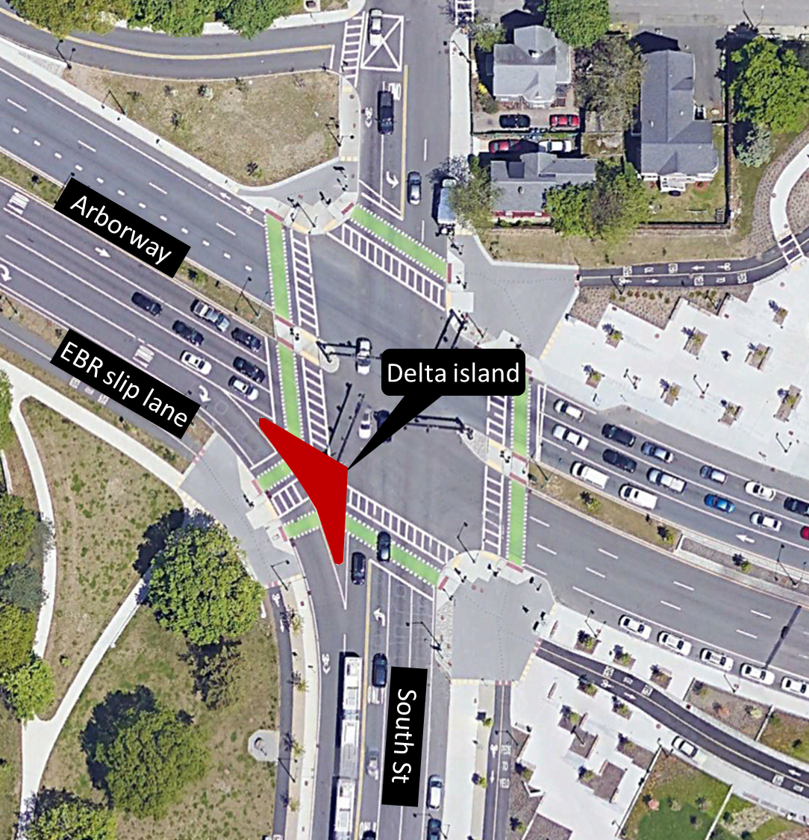
Fig. 1 South Street / Casey Arborway Intersection. (Annotation for EBR slip lane, delta island)
The current timing plan, as we observed it for the p.m. peak, is shown in Figure 2. Following convention, Phase 02 is the phase number given to the Arborway through movements, which are the coordinated phases. The cycle length is 120 s. We drew the cycle as if all phases have a fixed duration, because in most cycles we observed, it operated that way. However, it appears that the protected NBL movement in Phase 03 is programmed to have a variable length – a minimum green of 12 s that will it can extend to at least 17 s (that’s the longest we observed) as long as there is a queue in the left turn lane. (The sketch in Figure 2 shows “splits,” which includes the yellow and red clearance as well as green time.) If Phase 03 runs longer than shown, either Phase 04 or Phase 02 will be correspondingly shorter, so that the cycle remains fixed at 120 s.
As Figure 2 shows, the bike and pedestrian crossings across the slip lane also run during Phase 03. The Walk interval is 7 s, followed by 2 s of flashing don’t walk (FDW). Bikes get a green simultaneous with South Street’s NBL green arrow, therefore 12 s in most cycles.
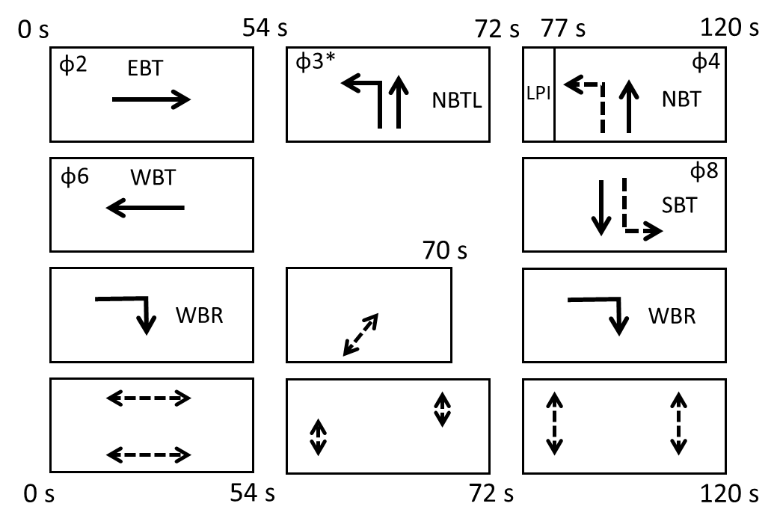
*Φ means “phase.” Phase 03 can vary in length from 18 s to 23 s, though in the p.m. peak, in most cyles, it lasts for 18 s. If it runs longer, one of the other phases is shortened correspondingly.
Figure 2. Current p.m. signal timing plan, South Street @ Casey Arborway
For both cyclists and pedestrians, there is a long delay waiting to cross the slip lane; that’s endemic to having a short phase in a long cycle. However, what makes waiting time intolerably long is that crossing the slip lane is only one part of a multi-stage crossing, and the main street crossings are not well coordinated with the slip lane crossing, forcing pedestrians and cyclists to wait, sometimes for a long time, on an intermediate island. For instance:
- a pedestrian headed eastbound across South Street will have to wait up to 110 s to cross the slip lane to the delta island, and will then have to wait there another 57 seconds before they can cross South Street.
- a cyclist riding southbound across Arborway will have to wait up to 87 s for their bike light to become green, but on reaching the delta island, will then have to wait another 84 seconds to get a green to cross the slip lane.
- a pedestrian crossing Arborway southbound will have to wait up to 111 s for a Walk signal to begin, but then will have to stop in the median, wait another 87 s to continue to the delta island, and then wait another 106 s to finish crossing.
Using the Northeastern University Pedestrian and Bike Crossing Delay Calculator, we created progression diagrams showing how the coordination between the signals governing the various stages of a person’s crossing affects when people can walk and when they must wait.
Figure 3 shows (a) the layout and progression diagrams for (b) pedestrians and (c) bikes crossing the western leg of Arborway. People walking or riding are represented by diagonal lines whose slope corresponds to an average walking / riding speed; people waiting are represented by horizontal lines. One can see, how southbound pedestrians have to wait to start their crossing, then wait on the median island, then wait again on the delta island. Southbound cyclists, for the most part, don’t have to wait at the median island, but have to endure a very long wait on the delta island. One can also see that coordination is much better – and delay smaller – for pedestrians and cyclists crossing northbound.

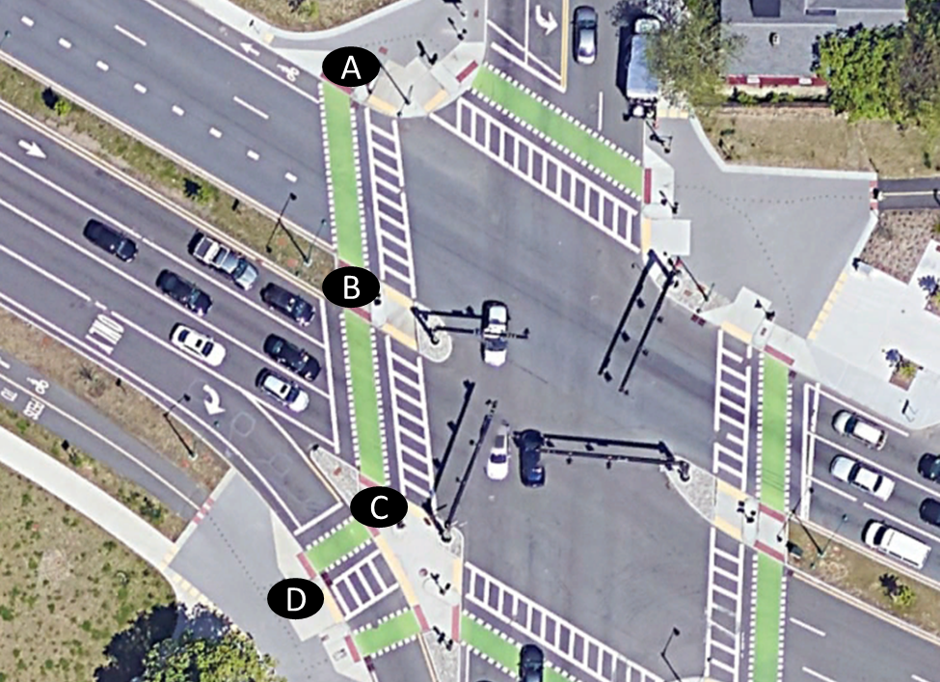
(a) Crossing layout
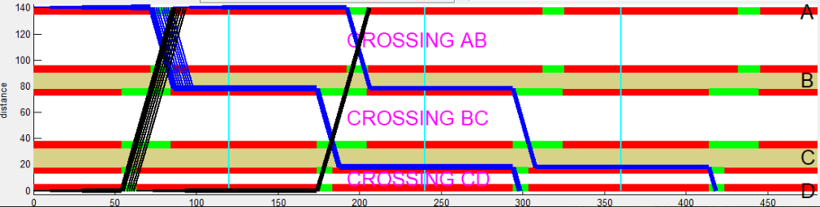
(b) for pedestrians
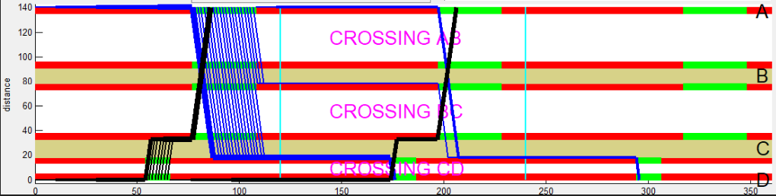
(c) for cyclists
Figure 3 Layout (a) and Progression Diagrams for crossing the western leg of Arborway at South Street for pedestrians (b) and for cyclists (c). Existing timing plan.

Figure 4 shows the layout and progression diagrams for (a) pedestrians and (b) cyclists crossing the southern leg of South Street. One can see the long wait on the delta island for people walking or riding eastbound (C-B-A), while those walking or riding westbound (A-B-C) have a shorter wait on the delta island.
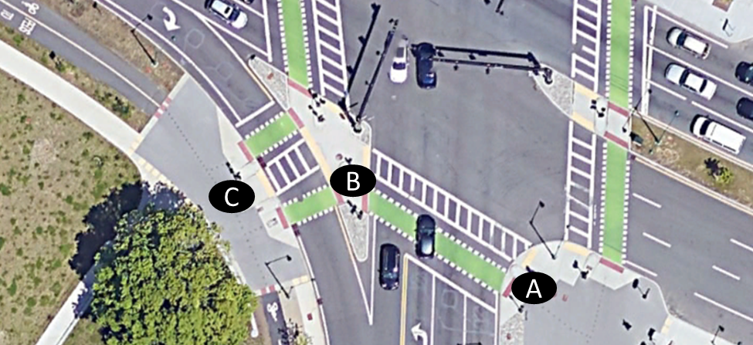
(a) Crossing layout
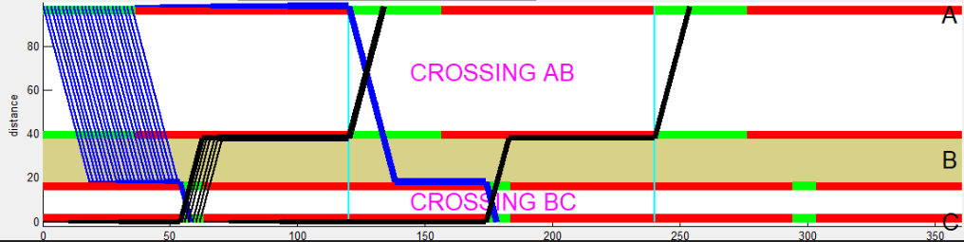
(b) for pedestrians
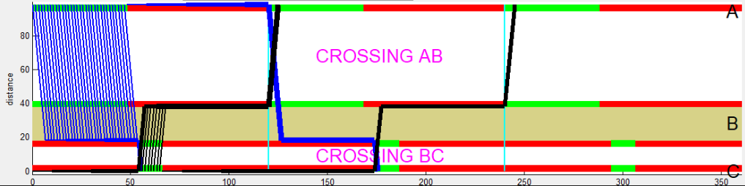
(c) for cyclists
Figure 4 Layout (a) and Progression Diagrams for crossing the southern leg of South Street at Casey Arborway for pedestrians (b) and for cyclists (c). Existing timing plan.

Average delay for all of the crossing movements that traverse the slip lane, determined using the Northeastern University Pedestrian and Bike Crossing Delay Calculator, are shown in Figure 5. The southbound crossings across Arborway have the worst service, with average delay of more than 240 s (more than 4 minutes!) for pedestrians and more than 120 s for bikes. Also shown for comparison are the much shorter average delays that result for the alternative signal timing plan that will be described later.

Figure 5: Average pedestrian and bicycle delay on the west and south leg crossings at the South St / Casey Arborway Intersection. Average delay greater than 60 s is Level of Service “F”.
For pedestrians and bikes, average waiting time in excess of 60 s is considered Level of Service F. An intersection that provides reasonably good service for autos (at least in most hours of the day) should not have Level of Service F for pedestrians and cyclists, especially not in a state or city that wants to promote walking and cycling as a sustainable means of transportation. Moreover, the Highway Capacity Manual states plainly that with pedestrian delay in this range, there is a high likelihood of pedestrian non-compliance. Indeed, one can see pedestrians and cyclists frequently crossing against the red. This is undesirable for safety because of how quickly cars approach on Arborway and because of how wide the other crossings are. Thus, reducing pedestrian and bicycle delay is not only a matter of convenience but also a matter of safety.

Fixing the Problem: An Alternative Signal Timing Plan
Where a slip lane is signalized and offers only a single, short crossing phase per cycle, it is impossible to provide good coordination for all but one or two of the crossing movements that include crossing the slip lane. To avoid having unacceptably long waiting times, there should be at least two slip lane crossing phases per cycle. This need for multiple slip lane crossings per cycle is well-established; we authored a peer-reviewed paper that explains it a few years ago (Furth, Peter G., Yue (Danny) Wang, and M.S. Santos, Multi-Stage Pedestrian Crossings and Two-Stage Bicycle Turns: Delay Estimation and Signal Timing Techniques for Limiting Pedestrian and Bicycle Delay. Journal of Transportation Technology 9:4, 2019).
At this intersection, the slip lane and the slip lane crossing conflict with no traffic movements except each other. The slip lane has a flow of about 600 veh/h during its busiest hour (p.m. peak); such a flow can be well served if EBR gets the green for at least 40% of the cycle. That means up to 60% of the cycle could be devoted to the slip lane crossing phases with no substantial impact on traffic. However, for pedestrians and cyclists, what is most important is not getting a single long phase, but rather getting multiple phases timed to coordinate well with their other crossings.
Figure 6 is an alternative signal timing plan for the p.m. peak that provides this good coordination. Except for the eastbound right slip lane, it essentially leaves traffic flow unchanged. Compared to the current plan, it alters the timing in three ways:
- It completely changes the slip lane (EBR) and slip lane crossing phases, while still ensuring plenty of green time for the EBR movement. There will now be two slip lane crossing intervals per cycle, timed to coordinate well with the main street crossing phases. Their durations are considerably longer than in the current plan in order to offer good coordination to pedestrians walking in both directions.
- It fixes the duration of Phase 03 (protected NB left) at 18s, making more of that phase available for pedestrians to have a Walk signal, and lengthens the concurrent Walk intervals correspondingly. That allows pedestrians to cross Arborway without having to stop in the median. The NBL movement already has a permitted phase following its protected left turn phase, during which vehicles can turn left even if they couldn’t fit into the protected turn phase.
- It eliminates the leading pedestrian interval (LPI) associated with the southbound movement (Phase 04) because it is a safety hazard to pedestrians, as explained later in this document.

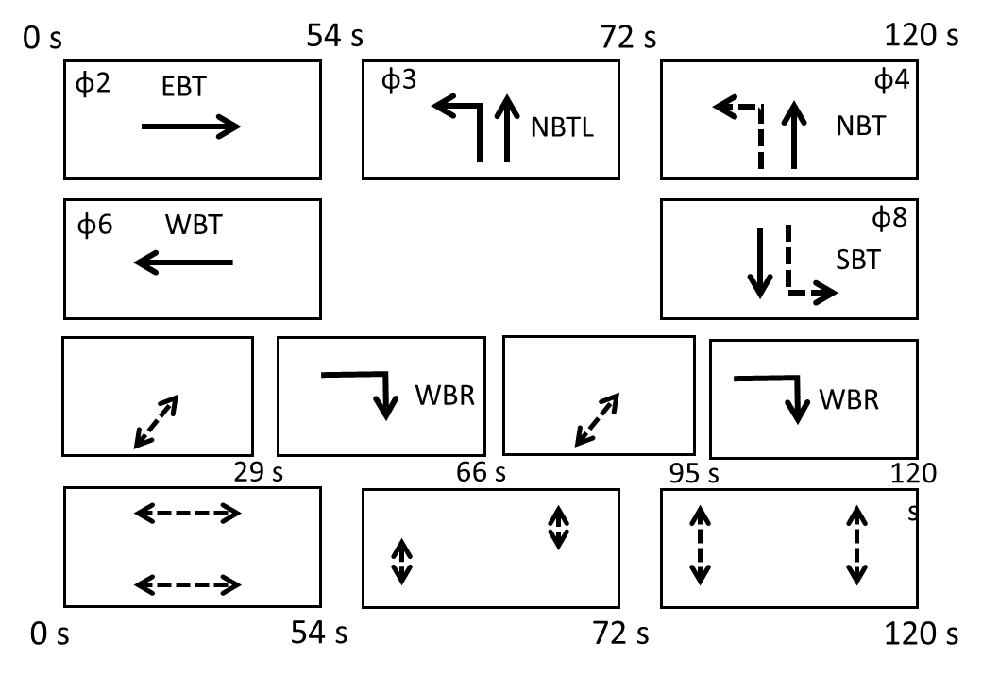
Figure 6 Alternative timing plan for South Street @ Casey Arborway

With this alternative timing plan, Figure 7 shows progression diagrams for crossing Arborway, and Figure 8 shows progression diagrams for crossing South Street. One can see how long waits on the islands are virtually eliminated, with several crossing becoming possible in a single pass while others involve only a short wait on an island.
(a) Crossing layout
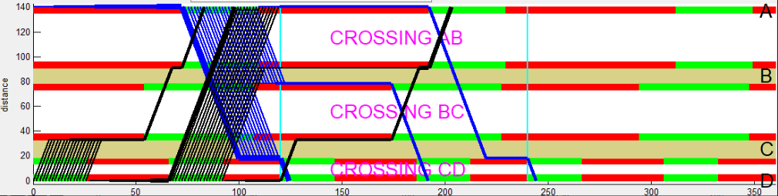
(b) For pedestrians
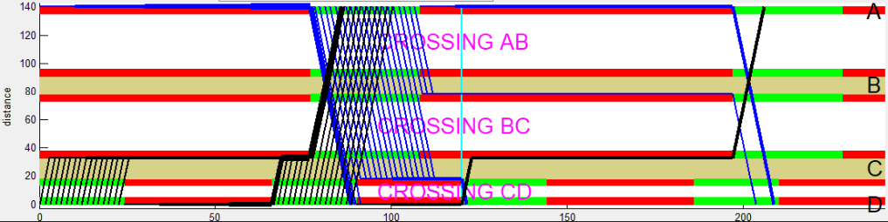
(c) for cyclists
Figure 7 Layout (a) and progression diagrams with the alternative timing plan, crossing the western leg of Arborway, for pedestrians (b) and for cyclists (c).
(a) For pedestrians
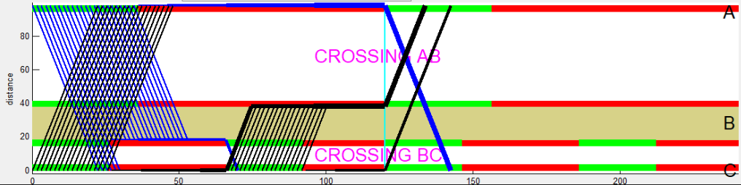
(b) for cyclists
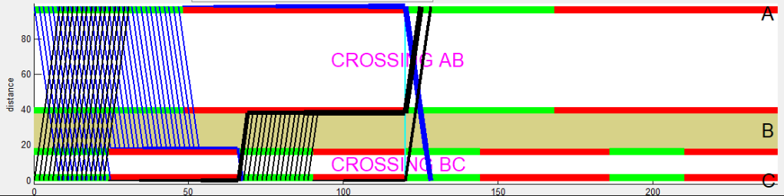
Figure 8 Layout (a) and progression diagrams with the alternative timing plan, crossing the southern leg of South Street, for pedestrians (b) and for cyclists (c).

As shown in Figure 5, average pedestrian and bike delay reductions with the alternative timing plan are dramatic. Taking a simple average over the four affected crossing directions:
- Average delay for pedestrians falls from 115 seconds to 38 seconds
- Average delay for bikes falls from 90 seconds to 38 seconds.
For the direction with the worst current service – southbound across the western leg of Casey Arborway – average pedestrian delay falls from 241 s to 52 s, and average bike delay falls from 121 s to 40 s.
Furthermore, by better coordinating crossing phases, queuing on the islands – whose capacity for pedestrians and bikes is limited – will be drastically reduced.
The proposed changes will affect vehicle flow in only two ways:
- Vehicles in the EBR traffic stream (i.e., using the slip lane), will see their average delay increase by about 10 seconds. The alternative plan still provides them will ample capacity – their total split is 62 s, and their effective green, after removing two change intervals, is 52 s, which is still more than enough for the traffic demand. Moreover, the proposed change may alleviate some congestion at the downstream intersection (South St @ Washington) because in the current plan, many of the vehicles turning right onto South Street do so while South Street southbound traffic has the green, creating a weaving conflict at the nearby intersection of South St and Washington Street, while in the alternative plan, most of the right turns run when South Street southbound traffic has red.
- With the LPI eliminated for the SB phase, there will be a small delay reduction for that phase.

2. Alleviating pedestrian danger from left turns and fixing poor / confusing bike service: Eliminate the LPI associated with the South Street SB phase
In speaking with a pedestrian who lives close to the intersection, we learned of a safety issue that is especially severe during the a.m. peak, though it can happen at other times as well. It involves pedestrians using the west side crosswalk across Arborway being harassed and challenged by left-turning cars, arriving northbound on South Street and then turning left onto Arborway. Ironincally, this hazard occurs because a leading pedestrian interval (LPI), something intended to protect pedestrians from turning vehicles.
Phase 04, the phase serving SBTR (southbound thru and right) traffic on South Street, currently begins with a 5 s leading pedestrian interval (LPI) that delays the start of SBTR green while the parallel crosswalk gets a Walk signal. Just before the LPI is Phase 03, serving NBL (northbound left) traffic with a protected arrow along with NBT traffic. As Phase 03 ends, NBL gets a yellow arrow, and then a red arrow, and then Phase 04 begins. But, due to the LPI, Phase 04 doesn’t begin by releasing opposing traffic (that is, SB traffic), but only by releasing pedestrians in the adjacent crosswalk. Only five seconds later does SB traffic get a green ball.
Unfortunately, the reality of Boston driver behavior is that when the NBL traffic stream sees its arrow turn to yellow and then red, they don’t actually stop; they keep going until they see opposing traffic beginning to move. Boston drivers do that at a lot of intersections, not just this one, which makes it a hard pattern to break. (This is the reason that whenever the City of Boston uses LPI’s, they change the left turn phase to lagging, such as along Mass. Ave. at Columbus Ave., at Tremont Street, and at Beacon Street.) What that means for pedestrians trying to cross Arborway is that when their Walk interval begins, they are getting challenged and harrassed by left-turning cars.
LPIs are intended to protect pedestrians from right turns at the start of the pedestrian phase. And so proposing eliminating an LPI may sound, on the surface, like it would harm pedestrians. But in this case, it’s quite the opposite. By releasing through traffic and pedestrians are released at the same time, the through traffic will protect the pedestrians from left turns, which present far greater danger to pedestrians than right turning cars (because left turning cars have greater speed and can follow an unpredicable, sweeping path as they enter a wide roadway). Moreover, danger from right turning cars is especially low at this location, because SBR volume is very low (we think it’s about 30 vehicles per hour, or one per cycle), and because the sharp turn angle ensures that any vehicle turning right will be going slowly. So overall, pedestrians would be better protected by getting rid of this LPI.
This LPI is also configured in a way that harms cyclists. During the 5 s leading walk interval, not only are motor vehicles on South Street SB held; so are bikes in the adjacent crossing! If an LPI offers protection from turning traffic, bikes need it, too! For bikes not to get an LPI is confusing – cyclists can’t understand why their signal should remain green for 5 more seconds after the pedestrians get a Walk signal. Undoubtedly, this configuration is the result of wiring signals the “easy” way by giving the bike signal the exact same feed going to the vehicle signal.
However, if, as we recommend, the LPI for this phase is eliminated in order to impove pedestrian safety, the problem of poor bike service disappears even if the bike signals remain tied to the vehicle signals.

B. Washington Street @ Casey Arborway: needed bike, bus, and pedestrian improvements

At the Washington / Arborway intersection, we saw needs to fix signal timing for buses, pedestrians, and bikes.

1. For buses: A priority bus left-turn phase whose abuse has perverted it into a bus disaster
The Casey Arborway project provided a westbound left turn lane from Arborway as a means for buses headed to Forest Hills Station to make a left turn. Autos are not supposed to use that lane during peak hours; there is a variable message sign that reads “<No Left Turn> Except Buses.” Because the left turn phase is supposed to serve only buses, it is green for only 7 or 8 s, enough for 3 vehicles per cycle.
We observed that vehicles that are not buses were rampantly using the left turn lane. We saw backups with 10 or more vehicles, with a bus at the tail of the queue. Because only about 3 vehicles can be served per cycle, buses can be caught there for multiple cycles. We observed one bus stuck in that lane for more than 6 minutes, and two others stuck for 4 to 5 minutes. We have reported this issue to the MBTA.
Either something should be done to enforce the No Left Turn (except buses) restriction, or time should be added to the left turn phase so that it clears every cycle, so that buses aren’t stuck waiting for several cycles to get through. (Making the left turn phase longer will increase congestion, however, because the eastbound through movement is at capacity.) In the medium term, a fix might be for the state to permit automated enforcement of bus lane violations from cameras on buses.

2. For pedestrians: Start the east side crossing earlier to avoid the current “delayed pededstrian interval” (the inverse of an LPI) entailing a conflict with high-speed right turns
In the current timing plan, the north-south half-cycle begins with Phase 03, lasting 12 s, serving NBL traffic as well as NBTR traffic. Then comes the main through phase for NB and SB, Phase 04. The pedestrian phases across Arborway run during Phase 04 only. This presents a safety hazard for pedestrians crossing the east leg and walking northbound. By the time they get their Walk, NB traffic – which started in Phase 03 – has been running for 12 s, and is therefore well established. This stream of traffic includes a lot of vehicles turning right onto Arborway, turning at high speed due to the oblique intersection angle and the wide receiving roadway. A pedestrian getting a Walk signal is being told to step into the middle of a stream of right-turning vehicles. This kind of “delayed pedestrian interval,” which the opposite of a leading pedestrian interval, is widely recognized as bad practice that should be avoided.
The obvious and simpe solution is to begin the east leg crossing during Phase 03. Not only would this alleviate the problem just described, it would also lower pedestrian delay. Because the pedestrian starting point is more than 100 ft distant from the stopline where NB traffic waits, pedestrians who begin at the same time as cars will have a substantial head start, and will be able to establish themselves in the crosswalk before the first right turning vehicle arrives. Thus, the intersection geometry makes it possible to achieve the goal of an LPI can be met without actually creating an LPI.
This change would mean timing the east side crosswalk differently from the west side crosswalk. On the west side, it is also possible to start the southern half-crossing Phase 03, as is done at the South St / Arborway intersection. While this change is not vital for safety, it would reduce delay for pedestrians walking northbound.

3. For bikes: Reconfigure signals so that bikes get a green during the LPI associated with Casey Arborway EB-WB
The eastbound and westbound through phases for Casey Arborway begin with a 5 s LPI, which help protect pedestrians from right turns. Bikes need the same protection, and there is no reason their signal should be red when the pedestrian phase right next to them has a Walk signal. The bike phases there should be reconfigured so that the bike green begins when the Walk phase begins.
If the bike signal can’t start during the LPI (for fear that drivers, seeing the bike green, will mistake it as their green), then a sign should be posted indicating that cyclists may follow the pedestrian signal.

